** The Knowledge City School**

**Mid-Term Examination (2019-20)**

**Class: I Paper: Mathematics**

|  |  |
| --- | --- |
| **Name:** | **Total Marks: 50** |
| **Date:** | **Total Marks obtained:** |
| **Paper setter: Sadia Batool** | **Time: 2 hours 30 mins** |

**Q1: Write in words. /5**

**27: \_\_\_\_\_\_\_\_\_\_\_\_\_\_\_\_\_\_\_\_\_\_**

**45: \_\_\_\_\_\_\_\_\_\_\_\_\_\_\_\_\_\_\_\_\_\_\_**

**9: \_\_\_\_\_\_\_\_\_\_\_\_\_\_\_\_\_\_\_\_\_\_\_\_**

**69: \_\_\_\_\_\_\_\_\_\_\_\_\_\_\_\_\_\_\_\_\_\_\_**

**80: \_\_\_\_\_\_\_\_\_\_\_\_\_\_\_\_\_\_\_\_\_\_\_**

**Q2: Fill in the banks. /3**

1. **10 and 5 make \_\_\_\_\_\_\_\_\_**
2. **10 and 8 make \_\_\_\_\_\_\_\_\_**
3. **10 and 1 make \_\_\_\_\_\_\_\_\_**
4. **10 and 4 make \_\_\_\_\_\_\_\_\_**
5. **10 and 6 make \_\_\_\_\_\_\_\_\_**

**f) 10 and 7 make \_\_\_\_\_\_\_\_\_**

**Q.2 Put these numbers in order.Begin with the greatest /4**

**a) 79 70 92**

**b) 63 57 75**

**c) 34 67 43**

**d) 28 87 98**

**Q3: Write the numbers in correct order. Begin with the smallest. /4**

**a) 50 47 51**

1. **36 34 37**
2. **80 68 81**

1. **59 95 90**

**Q.4 Add 8**

**(a) 12 + 4 = \_\_\_\_\_\_**

**------- + -------- = -----------**

**-------- + --------- = ----------**

**b) 17 + 2 = \_\_\_\_\_\_\_\_\_**

**--------- + -------- = -----------**

**---------- + --------- = ----------**

**c) 15 + 3 = \_\_\_\_\_\_\_**

**--------- + -------- = -----------**

**---------- + --------- = ----------**

**Q.5 Subtract /8**

**a) 15 – 4 = \_\_\_\_\_\_\_\_\_\_**

**------ - ------- = -------**

**--------- + ------- = -----------**

**b) 18 - 5 = \_\_\_\_\_\_\_\_\_\_**

**------ - ------- = -----------**

**-------- + -------- = ---------**

**c) 19 - 5 = \_\_\_\_\_\_\_\_\_**

**------ - ------- = -----------**

**-------- + -------- = ---------**

**Q5: Addition /4**

**Tens Ones Tens Ones**

**7 4 6 8**

**+ 4 5 + 4 1**

**\_\_\_\_\_\_\_\_\_\_\_\_\_\_\_\_\_\_\_ \_\_\_\_\_\_\_\_\_\_\_\_\_\_\_\_\_\_\_\_\_\_**

**\_\_\_\_\_\_\_\_\_\_\_\_\_\_\_\_\_\_ \_\_\_\_\_\_\_\_\_\_\_\_\_\_\_\_\_\_\_\_\_\_\_**

**Q6: Subtract /4**

**Tens Ones Tens Ones**

**8 3 9 7**

**- 4 2 - 5 4**

**\_\_\_\_\_\_\_\_\_\_\_\_\_\_\_\_\_\_\_ \_\_\_\_\_\_\_\_\_\_\_\_\_\_\_\_\_\_\_\_\_\_**

**\_\_\_\_\_\_\_\_\_\_\_\_\_\_\_\_\_\_\_\_ \_\_\_\_\_\_\_\_\_\_\_\_\_\_\_\_\_\_\_\_\_\_**

**Q8: Sally has 5 flowers. Linda gives her 4 flowers. How many flowers does sally have altogether? \2**

**Q9: There are 5 men on the lorry. 2 men get off. How many men are there left on the lorry? /2**

**Q10. There are 4 oranges and 2 bananas. How many fewer bananas than oranges are there? /2**

**Q10: Complete the number bonds. \4**

** The Knowledge City School**

**Mid-Term Examination (2019-20)**

**Class: I Paper: English**

|  |  |
| --- | --- |
| **Name:** | **Total Marks: 50** |
| **Date:** | **Total Marks obtained:** |
| **Paper setter: Rajaa Fatima** | **Time: 2 hours 30 mins** |

**Class Evaluation: /5**

**Reading /5**

**listening /5**

**speaking /5**

**spell check /5**

**Q1. Spell check /5**

1. **\_\_\_\_\_\_\_\_\_\_\_\_\_\_\_\_\_**
2. **\_\_\_\_\_\_\_\_\_\_\_\_\_\_\_\_\_**
3. **\_\_\_\_\_\_\_\_\_\_\_\_\_\_\_\_\_**
4. **\_\_\_\_\_\_\_\_\_\_\_\_\_\_\_\_\_**
5. **\_\_\_\_\_\_\_\_\_\_\_\_\_\_\_\_\_**
6. **\_\_\_\_\_\_\_\_\_\_\_\_\_\_\_\_\_**
7. **\_\_\_\_\_\_\_\_\_\_\_\_\_\_\_\_\_**
8. **\_\_\_\_\_\_\_\_\_\_\_\_\_\_\_\_\_**
9. **\_\_\_\_\_\_\_\_\_\_\_\_\_\_\_\_\_**
10. **\_\_\_\_\_\_\_\_\_\_\_\_\_\_\_\_\_**

**Q2. Write down the noun with the correct picture. /3**

|  |
| --- |
| **Rope Tree Paw Elephant Rat Crown** |

**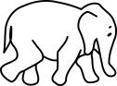 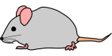 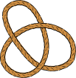  C:\Users\pak\AppData\Local\Microsoft\Windows\INetCache\IE\GX9XM06M\crown-304838_960_720[1].png **

**\_\_\_\_\_\_\_\_\_\_\_\_ \_\_\_\_\_\_\_ \_\_\_\_\_\_\_\_ \_\_\_\_\_\_\_ \_\_\_\_\_\_\_\_ \_\_\_\_\_**

**Q3. Choose the correct word. /3**

1. **A lion is a wild \_\_\_\_\_\_\_\_. (dog, rat, cat)**
2. **The lion is the king of the \_\_\_\_\_\_\_\_\_\_\_. (castle, country, jungle)**
3. **The lion walked into a \_\_\_\_\_\_\_\_\_\_\_. (house, farm, trap)**
4. **The mouse \_\_\_\_\_\_\_\_\_\_\_\_\_\_\_ the rope. (nibbled, tore, broke)**
5. **The lion \_\_\_\_\_\_\_\_\_\_\_\_\_\_ the mouse. (thanked, killed, ate)**
6. **The mouse saved the lion's \_\_\_\_\_\_\_\_\_\_\_. (cub, life, money)**

**Q4. Complete these words by adding "ou" or "y" /2**

**L\_ \_d**

**Part\_**

**tid\_**

**p\_ \_nd**

**Q5. Put ? or - at the end of a statement. /5**

1. **I was playing**
2. **Did you go to the party**
3. **Sara was laughing**
4. **Traffic rules should be followed**
5. **Hassan was trying to cross the road**
6. **Shall we go out**
7. **My little sister got happy**
8. **Did Dora play**
9. **Alia was running**
10. **Did Jawad study**

**Q6. Make sentences of the following /5**

|  |  |
| --- | --- |
| **out** |  |
| **mouse** |  |
| **hot** |  |
| **fat** |  |
| **peach** |  |
| **cat** |  |
| **green** |  |
| **balloon** |  |
| **took** |  |
| **nine** |  |

**Q7. Comprehension passage.**

**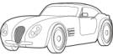rico's class went to the burberry zoo today. it was a lot of fun. rico won two prizes. he won a blue balloon and a toy car. he had a great time with all of his friends. first he played a few games. then he got popcorn and lemonade with his friends. finally he watched a magic show. rico can't wait to get back to home and tell his parents all about his fun day.**

**i) Circle the letter where capitalization is needed. /2.5**

**Answer these questions /5**

**1. Where did Rico's class go?**

**\_\_\_\_\_\_\_\_\_\_\_\_\_\_\_\_\_\_\_\_\_\_\_\_\_\_\_\_\_\_\_\_\_\_\_\_\_\_\_\_\_\_\_\_\_\_\_\_\_\_\_\_\_\_\_\_\_\_\_\_\_\_\_\_\_\_\_\_\_\_\_\_\_\_\_\_\_\_\_\_\_\_\_\_\_\_\_\_\_\_\_\_\_\_\_\_\_\_\_\_\_\_\_\_\_\_\_\_\_\_\_\_\_\_\_\_\_\_\_\_\_\_\_\_\_\_\_\_\_\_\_\_\_\_\_\_\_\_\_\_\_\_\_\_\_\_\_\_\_\_\_\_\_\_\_\_\_\_\_\_\_\_\_\_**

**2. What did Rico win?**

**\_\_\_\_\_\_\_\_\_\_\_\_\_\_\_\_\_\_\_\_\_\_\_\_\_\_\_\_\_\_\_\_\_\_\_\_\_\_\_\_\_\_\_\_\_\_\_\_\_\_\_\_\_\_\_\_\_\_\_\_\_\_\_\_\_\_\_\_\_\_\_\_\_\_\_\_\_\_\_\_\_\_\_\_\_\_\_\_\_\_\_\_\_\_\_\_\_\_\_\_\_\_\_\_\_\_\_\_\_\_\_\_\_\_\_\_\_\_\_\_\_\_\_\_\_\_\_\_\_\_\_\_\_\_\_\_\_\_\_\_\_\_\_\_\_\_\_\_\_\_\_\_\_\_\_\_\_\_\_\_\_\_\_\_**

**3. What did he do first?**

**\_\_\_\_\_\_\_\_\_\_\_\_\_\_\_\_\_\_\_\_\_\_\_\_\_\_\_\_\_\_\_\_\_\_\_\_\_\_\_\_\_\_\_\_\_\_\_\_\_\_\_\_\_\_\_\_\_\_\_\_\_\_\_\_\_\_\_\_\_\_\_\_\_\_\_\_\_\_\_\_\_\_\_\_\_\_\_\_\_\_\_\_\_\_\_\_\_\_\_\_\_\_\_\_\_\_\_\_\_\_\_\_\_\_\_\_\_\_\_\_\_\_\_\_\_\_\_\_\_\_\_\_\_\_\_\_\_\_\_\_\_\_\_\_\_\_\_\_\_\_\_\_\_\_\_\_\_\_\_\_\_\_\_\_**

**4. What did Rico eat?**

**\_\_\_\_\_\_\_\_\_\_\_\_\_\_\_\_\_\_\_\_\_\_\_\_\_\_\_\_\_\_\_\_\_\_\_\_\_\_\_\_\_\_\_\_\_\_\_\_\_\_\_\_\_\_\_\_\_\_\_\_\_\_\_\_\_\_\_\_\_\_\_\_\_\_\_\_\_\_\_\_\_\_\_\_\_\_\_\_\_\_\_\_\_\_\_\_\_\_\_\_\_\_\_\_\_\_\_\_\_\_\_\_\_\_\_\_\_\_\_\_\_\_\_\_\_\_\_\_\_\_\_\_\_\_\_\_\_\_\_\_\_\_\_\_\_\_\_\_\_\_\_\_\_\_\_\_\_\_\_\_\_\_\_\_**

**5. Suggest a title for the passage.**

**\_\_\_\_\_\_\_\_\_\_\_\_\_\_\_\_\_\_\_\_\_\_\_\_\_\_\_\_\_\_\_\_\_\_\_\_\_\_\_\_\_\_\_\_\_\_\_\_\_\_\_\_\_\_\_\_\_\_\_\_\_\_\_\_\_\_\_\_\_\_\_\_\_\_\_\_\_\_\_\_\_\_\_\_\_\_\_\_\_\_\_\_\_\_\_\_\_\_\_\_\_\_\_\_\_\_\_\_\_\_\_\_\_\_\_\_\_\_\_\_\_\_\_\_\_\_\_\_\_\_\_\_\_\_\_\_\_\_\_\_\_\_\_\_\_\_\_\_\_\_\_\_\_\_\_\_\_\_\_\_\_\_\_\_**

**Q8. Write "T" for true and "F" for false /2.5**

1. **Rico went to the market.**
2. **He got bored.**
3. **Rico won two prizes**
4. **He played few games**
5. **He did not watch a magic show.**

**Q9. Answer these questions. /8**

1. **Describe the balloons which the balloon man had?**

**\_\_\_\_\_\_\_\_\_\_\_\_\_\_\_\_\_\_\_\_\_\_\_\_\_\_\_\_\_\_\_\_\_\_\_\_\_\_\_\_\_\_\_\_\_\_\_\_\_\_\_\_\_\_\_\_\_\_\_\_\_\_\_\_\_\_\_\_\_\_\_\_\_\_\_\_\_\_\_\_\_\_\_\_\_\_\_\_\_\_\_\_\_\_**

**2. Who was looking at the balloon man?**

**\_\_\_\_\_\_\_\_\_\_\_\_\_\_\_\_\_\_\_\_\_\_\_\_\_\_\_\_\_\_\_\_\_\_\_\_\_\_\_\_\_\_\_\_\_\_\_\_\_\_\_\_\_\_\_\_\_\_\_\_\_\_\_\_\_\_\_\_\_\_\_\_\_\_\_\_\_\_\_\_\_\_\_\_\_\_\_\_\_\_\_\_\_\_\_**

**3. Where does the parrot sit?**

**\_\_\_\_\_\_\_\_\_\_\_\_\_\_\_\_\_\_\_\_\_\_\_\_\_\_\_\_\_\_\_\_\_\_\_\_\_\_\_\_\_\_\_\_\_\_\_\_\_\_\_\_\_\_\_\_\_\_\_\_\_\_\_\_\_\_\_\_\_\_\_\_\_\_\_\_\_\_\_\_\_\_\_\_\_\_\_\_\_\_\_\_\_\_\_**

**4. What is the parrot called?**

**Q10. Picture description. /4**

**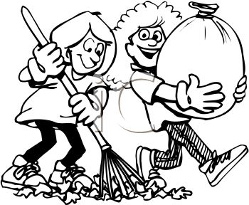**

|  |
| --- |
| **Two, children, broom, boy, girl, bundle, happy, clean** |

**Q11. Write a paragraph on "Why a Plants useful " and draw a picture related to it and color it. /4**

|  |
| --- |
| **Greenery, healthy, food, fruit, vegetables, shadow, oxygen.** |

**Picture of a plant /1**

|  |
| --- |
|  |

** The Knowledge City School**

**Mid-Term Examination (2019-20)**

**Class: I Paper: Arts**

|  |  |
| --- | --- |
| **Name:** | **Total Marks: 50** |
| **Date:** | **Total Marks obtained:** |
| **Paper setter: MS Zaheen** | **Time: 2 hours 30 mins** |

**Q1.Color the given picture. /10**

**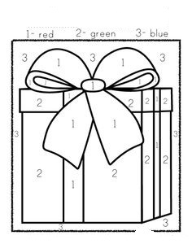**

**Q2.See and draw. /10**

**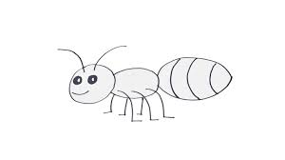**

**Q3.Complete the picture. /10**

**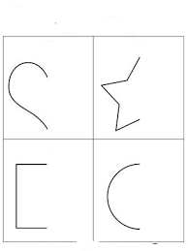**

**Q4.Draw a park. /10**

**Note:10 marks for notebook**

** The Knowledge City School**

**Mid-Term Examination (2019-20)**

**Class: Il Paper: English**

|  |  |
| --- | --- |
| **Name:** | **Total Marks: 50** |
| **Date:** | **Total Marks obtained:** |
| **Paper setter: Rajaa Fatima** | **Time: 2 hours 30 mins** |

**Class Evaluation: /5**

**Reading /5**

**listening /5**

**speaking /5**

**spell check /5**

**Q1. Spell check /5**

**1.\_\_\_\_\_\_\_\_\_\_\_\_\_\_\_\_\_**

**2.\_\_\_\_\_\_\_\_\_\_\_\_\_\_\_\_\_**

**3.\_\_\_\_\_\_\_\_\_\_\_\_\_\_\_\_\_**

**4.\_\_\_\_\_\_\_\_\_\_\_\_\_\_\_\_\_**

**5.\_\_\_\_\_\_\_\_\_\_\_\_\_\_\_\_\_**

**6.\_\_\_\_\_\_\_\_\_\_\_\_\_\_\_\_\_**

**7.\_\_\_\_\_\_\_\_\_\_\_\_\_\_\_\_\_**

**8.\_\_\_\_\_\_\_\_\_\_\_\_\_\_\_\_\_**

**9.\_\_\_\_\_\_\_\_\_\_\_\_\_\_\_\_\_**

**10.\_\_\_\_\_\_\_\_\_\_\_\_\_\_\_\_\_**

**Q. Unscramble these letters. /3**

1. **pyupp \_\_\_\_\_\_\_\_\_\_\_\_\_**
2. **apshla \_\_\_\_\_\_\_\_\_\_\_\_\_**
3. **ickst \_\_\_\_\_\_\_\_\_\_\_\_\_\_**
4. **ydr \_\_\_\_\_\_\_\_\_\_\_\_\_**
5. **edbark \_\_\_\_\_\_\_\_\_\_\_\_\_**
6. **mohe \_\_\_\_\_\_\_\_\_\_\_\_**

**Q. Write these sentences correctly. /3**

1. **Meera and i were going to the party.**

**\_\_\_\_\_\_\_\_\_\_\_\_\_\_\_\_\_\_\_\_\_\_\_\_\_\_\_\_\_\_\_\_\_\_\_\_\_\_\_\_\_\_\_\_\_\_\_\_\_\_\_\_\_\_\_\_\_\_\_\_\_\_\_\_\_\_\_\_\_\_\_\_\_\_\_**

1. **i wish she was going to the party.**

**\_\_\_\_\_\_\_\_\_\_\_\_\_\_\_\_\_\_\_\_\_\_\_\_\_\_\_\_\_\_\_\_\_\_\_\_\_\_\_\_\_\_\_\_\_\_\_\_\_\_\_\_\_\_\_\_\_\_\_\_\_\_\_\_\_\_\_\_\_\_\_\_\_\_\_**

1. **i said he was sick.**

**\_\_\_\_\_\_\_\_\_\_\_\_\_\_\_\_\_\_\_\_\_\_\_\_\_\_\_\_\_\_\_\_\_\_\_\_\_\_\_\_\_\_\_\_\_\_\_\_\_\_\_\_\_\_\_\_\_\_\_\_\_\_\_\_\_\_\_\_\_\_\_\_\_\_\_**

1. **i like apples but she prefers bananas.**

**\_\_\_\_\_\_\_\_\_\_\_\_\_\_\_\_\_\_\_\_\_\_\_\_\_\_\_\_\_\_\_\_\_\_\_\_\_\_\_\_\_\_\_\_\_\_\_\_\_\_\_\_\_\_\_\_\_\_\_\_\_\_\_\_\_\_\_\_\_\_\_\_\_\_\_**

1. **i wish they could sing a song.**

**\_\_\_\_\_\_\_\_\_\_\_\_\_\_\_\_\_\_\_\_\_\_\_\_\_\_\_\_\_\_\_\_\_\_\_\_\_\_\_\_\_\_\_\_\_\_\_\_\_\_\_\_\_\_\_\_\_\_\_\_\_\_\_\_\_\_\_\_\_\_\_\_\_\_\_**

1. **Dad and i could go so we were going.**

**\_\_\_\_\_\_\_\_\_\_\_\_\_\_\_\_\_\_\_\_\_\_\_\_\_\_\_\_\_\_\_\_\_\_\_\_\_\_\_\_\_\_\_\_\_\_\_\_\_\_\_\_\_\_\_\_\_\_\_\_\_\_\_\_\_\_\_\_\_\_\_\_\_\_\_**

**Q. Write two sentences for each picture. /10**

**1.\_\_\_\_\_\_\_\_\_\_\_\_\_\_\_\_\_\_\_\_\_\_\_\_\_\_\_\_\_\_\_\_\_\_\_\_\_\_\_\_\_\_\_\_\_\_\_\_\_\_\_\_\_\_\_\_\_\_\_\_\_\_\_\_\_\_\_\_\_\_\_\_\_\_\_**

**2.\_\_\_\_\_\_\_\_\_\_\_\_\_\_\_\_\_\_\_\_\_\_\_\_\_\_\_\_\_\_\_\_\_\_\_\_\_\_\_\_\_\_\_\_\_\_\_\_\_\_\_\_\_\_\_\_\_\_\_\_\_\_\_\_\_\_\_\_\_\_\_\_\_\_\_**

**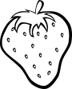**

**1.\_\_\_\_\_\_\_\_\_\_\_\_\_\_\_\_\_\_\_\_\_\_\_\_\_\_\_\_\_\_\_\_\_\_\_\_\_\_\_\_\_\_\_\_\_\_\_\_\_\_\_\_\_\_\_\_\_\_\_\_\_\_\_\_\_\_\_\_\_\_\_\_\_\_\_**

**2.\_\_\_\_\_\_\_\_\_\_\_\_\_\_\_\_\_\_\_\_\_\_\_\_\_\_\_\_\_\_\_\_\_\_\_\_\_\_\_\_\_\_\_\_\_\_\_\_\_\_\_\_\_\_\_\_\_\_\_\_\_\_\_\_\_\_\_\_\_\_\_\_\_\_\_**

**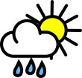1.\_\_\_\_\_\_\_\_\_\_\_\_\_\_\_\_\_\_\_\_\_\_\_\_\_\_\_\_\_\_\_\_\_\_\_\_\_\_\_\_\_\_\_\_\_\_\_\_\_\_\_\_\_\_\_\_\_\_\_\_\_\_\_\_\_\_\_\_\_\_\_\_\_\_\_**

**2.\_\_\_\_\_\_\_\_\_\_\_\_\_\_\_\_\_\_\_\_\_\_\_\_\_\_\_\_\_\_\_\_\_\_\_\_\_\_\_\_\_\_\_\_\_\_\_\_\_\_\_\_\_\_\_\_\_\_\_\_\_\_\_\_\_\_\_\_\_\_\_\_\_\_\_**

****

**1. \_\_\_\_\_\_\_\_\_\_\_\_\_\_\_\_\_\_\_\_\_\_\_\_\_\_\_\_\_\_\_\_\_\_\_\_\_\_\_\_\_\_\_\_\_\_\_\_\_\_\_\_\_\_\_\_\_\_\_\_\_\_\_\_\_\_\_\_\_\_\_\_\_\_\_\_\_\_\_**

**2.\_\_\_\_\_\_\_\_\_\_\_\_\_\_\_\_\_\_\_\_\_\_\_\_\_\_\_\_\_\_\_\_\_\_\_\_\_\_\_\_\_\_\_\_\_\_\_\_\_\_\_\_\_\_\_\_\_\_\_\_\_\_\_\_\_\_\_\_\_\_\_\_\_\_\_\_\_\_\_**

****

**1.\_\_\_\_\_\_\_\_\_\_\_\_\_\_\_\_\_\_\_\_\_\_\_\_\_\_\_\_\_\_\_\_\_\_\_\_\_\_\_\_\_\_\_\_\_\_\_\_\_\_\_\_\_\_\_\_\_\_\_\_\_\_\_\_\_\_\_\_\_\_\_\_\_\_\_\_\_\_\_\_**

**2.\_\_\_\_\_\_\_\_\_\_\_\_\_\_\_\_\_\_\_\_\_\_\_\_\_\_\_\_\_\_\_\_\_\_\_\_\_\_\_\_\_\_\_\_\_\_\_\_\_\_\_\_\_\_\_\_\_\_\_\_\_\_\_\_\_\_\_\_\_\_\_\_\_\_\_\_\_\_\_\_**

**Q. Comprehension passage.**

**do not go out without your warm coat. tom it is very cold, and the snow lies thick on the ground. if you do then you will catch cold, and then poor tom will be ill, said the mother.**

**"but I feel quite warm" tom said. yes you do now, but see we have indoor fire, outdoor there is no fire, and the cold wind blows, and if you have no warm coat you will feel cold, said the mother.**

**but tom thought he knew best, so he went outside with no coat on and he caught a bad cold and cough. when he was in bed he thought, how silly he had been and then he said to himself that he would try and do all that he was told when he gets well.**

**Circle the letter where capitalization is needed. /2.5**

**Answer these questions. /6**

**1. What was the weather outside?**

**\_\_\_\_\_\_\_\_\_\_\_\_\_\_\_\_\_\_\_\_\_\_\_\_\_\_\_\_\_\_\_\_\_\_\_\_\_\_\_\_\_\_\_\_\_\_\_\_\_\_\_\_\_\_\_\_\_\_\_\_\_\_\_\_\_\_\_\_\_\_\_\_\_\_\_\_\_\_\_\_\_\_\_\_\_\_\_\_\_\_\_\_\_\_\_\_\_\_\_\_\_\_\_\_\_\_\_\_\_\_\_\_\_\_\_\_\_\_\_\_\_\_\_\_\_\_\_\_\_\_\_\_\_\_\_\_\_\_\_\_\_\_\_\_\_\_\_\_\_\_\_\_\_\_\_\_\_\_\_\_\_\_\_\_**

**2. What was Tom asked to do before going outside?**

**\_\_\_\_\_\_\_\_\_\_\_\_\_\_\_\_\_\_\_\_\_\_\_\_\_\_\_\_\_\_\_\_\_\_\_\_\_\_\_\_\_\_\_\_\_\_\_\_\_\_\_\_\_\_\_\_\_\_\_\_\_\_\_\_\_\_\_\_\_\_\_\_\_\_\_\_\_\_\_\_\_\_\_\_\_\_\_\_\_\_\_\_\_\_\_\_\_\_\_\_\_\_\_\_\_\_\_\_\_\_\_\_\_\_\_\_\_\_\_\_\_\_\_\_\_\_\_\_\_\_\_\_\_\_\_\_\_\_\_\_\_\_\_\_\_\_\_\_\_\_\_\_\_\_\_\_\_\_\_\_\_\_\_\_**

**3. Why does Tom think he doesn't need a coat?**

**\_\_\_\_\_\_\_\_\_\_\_\_\_\_\_\_\_\_\_\_\_\_\_\_\_\_\_\_\_\_\_\_\_\_\_\_\_\_\_\_\_\_\_\_\_\_\_\_\_\_\_\_\_\_\_\_\_\_\_\_\_\_\_\_\_\_\_\_\_\_\_\_\_\_\_\_\_\_\_\_\_\_\_\_\_\_\_\_\_\_\_\_\_\_\_\_\_\_\_\_\_\_\_\_\_\_\_\_\_\_\_\_\_\_\_\_\_\_\_\_\_\_\_\_\_\_\_\_\_\_\_\_\_\_\_\_\_\_\_\_\_\_\_\_\_\_\_\_\_\_\_\_\_\_\_\_\_\_\_\_\_\_\_\_**

**4.What happened when Tom went outside without a coat?**

**\_\_\_\_\_\_\_\_\_\_\_\_\_\_\_\_\_\_\_\_\_\_\_\_\_\_\_\_\_\_\_\_\_\_\_\_\_\_\_\_\_\_\_\_\_\_\_\_\_\_\_\_\_\_\_\_\_\_\_\_\_\_\_\_\_\_\_\_\_\_\_\_\_\_\_\_\_\_\_\_\_\_\_\_\_\_\_\_\_\_\_\_\_\_\_\_\_\_\_\_\_\_\_\_\_\_\_\_\_\_\_\_\_\_\_\_\_\_\_\_\_\_\_\_\_\_\_\_\_\_\_\_\_\_\_\_\_\_\_\_\_\_\_\_\_\_\_\_\_\_\_\_\_\_\_\_\_\_\_\_\_\_\_\_**

**5. Why did Tom think he had been silly?**

**\_\_\_\_\_\_\_\_\_\_\_\_\_\_\_\_\_\_\_\_\_\_\_\_\_\_\_\_\_\_\_\_\_\_\_\_\_\_\_\_\_\_\_\_\_\_\_\_\_\_\_\_\_\_\_\_\_\_\_\_\_\_\_\_\_\_\_\_\_\_\_\_\_\_\_\_\_\_\_\_\_\_\_\_\_\_\_\_\_\_\_\_\_\_\_\_\_\_\_\_\_\_\_\_\_\_\_\_\_\_\_\_\_\_\_\_\_\_\_\_\_\_\_\_\_\_\_\_\_\_\_\_\_\_\_\_\_\_\_\_\_\_\_\_\_\_\_\_\_\_\_\_\_\_\_\_\_\_\_\_\_\_\_\_**

**6. Suggest a title for the passage.**

**\_\_\_\_\_\_\_\_\_\_\_\_\_\_\_\_\_\_\_\_\_\_\_\_\_\_\_\_\_\_\_\_\_\_\_\_\_\_\_\_\_\_\_\_\_\_\_\_\_\_\_\_\_\_\_\_\_\_\_\_\_\_\_\_\_\_\_\_\_\_\_\_\_\_\_\_\_\_\_\_\_\_\_\_\_\_\_\_\_\_\_\_\_\_\_\_\_\_\_\_\_\_\_\_\_\_\_\_\_\_\_\_\_\_\_\_\_\_\_\_\_\_\_\_\_\_\_\_\_\_\_\_\_\_\_\_\_\_\_\_\_\_\_\_\_\_\_\_\_\_\_\_\_\_\_\_\_\_\_\_\_\_\_\_**

**Write "T" for true and "F" for false statement. /2.5**

1. **It was summer season.**
2. **Tom wanted to stay inside the house.**
3. **There was snow outside the house.**
4. **Tom got bad cold and cough.**
5. **Tom thought that he would have listened to his mother.**

**Q. Picture description. /4**

****

|  |
| --- |
| **Hygiene, tooth brush, happy, tooth paste, twice, cleanliness, healthy** |

**Q. Write a paragraph on "My favorite TV show". /4**

|  |
| --- |
| **Program, watch, family, time, like, happy, favorite** |

**Q. Write dialogue among two sisters about a present they would give to their younger sister. /3**

|  |
| --- |
| **beautiful, color, happy, love, like,** |

**Q. Answer these questions. /8**

**1. Why did Farmer Ben look funny?**

**\_\_\_\_\_\_\_\_\_\_\_\_\_\_\_\_\_\_\_\_\_\_\_\_\_\_\_\_\_\_\_\_\_\_\_\_\_\_\_\_\_\_\_\_\_\_\_\_\_\_\_\_\_\_\_\_\_\_\_\_\_\_\_\_\_\_\_\_\_\_\_\_\_\_\_\_\_\_\_\_\_\_\_\_\_\_\_\_\_\_\_\_\_\_\_**

**2. What was A? What was good about it?**

**\_\_\_\_\_\_\_\_\_\_\_\_\_\_\_\_\_\_\_\_\_\_\_\_\_\_\_\_\_\_\_\_\_\_\_\_\_\_\_\_\_\_\_\_\_\_\_\_\_\_\_\_\_\_\_\_\_\_\_\_\_\_\_\_\_\_\_\_\_\_\_\_\_\_\_\_\_\_\_\_\_\_\_\_\_\_\_\_\_\_\_\_\_\_**

**3. What did chicken licken want to tell the king?**

**\_\_\_\_\_\_\_\_\_\_\_\_\_\_\_\_\_\_\_\_\_\_\_\_\_\_\_\_\_\_\_\_\_\_\_\_\_\_\_\_\_\_\_\_\_\_\_\_\_\_\_\_\_\_\_\_\_\_\_\_\_\_\_\_\_\_\_\_\_\_\_\_\_\_\_\_\_\_\_\_\_\_\_\_\_\_\_\_\_\_\_\_\_\_**

**4. Who is Mr.Plod and what does he look like?**

**\_\_\_\_\_\_\_\_\_\_\_\_\_\_\_\_\_\_\_\_\_\_\_\_\_\_\_\_\_\_\_\_\_\_\_\_\_\_\_\_\_\_\_\_\_\_\_\_\_\_\_\_\_\_\_\_\_\_\_\_\_\_\_\_\_\_\_\_\_\_\_\_\_\_\_\_\_\_\_\_\_\_\_\_\_\_\_\_\_\_\_\_\_\_\_**

****

**The Knowledge City School**

**Mid-Term Examination (2019-20)**

**Class: Il Paper: Mathematics**

|  |  |
| --- | --- |
| **Name:** | **Total Marks: 50** |
| **Date:** | **Total Marks obtained:** |
| **Paper setter:Marium Batool** | **Time: 2 hours 30 mins** |

**Q1: Write in words (5)**

1. **786 \_\_\_\_\_\_\_\_\_\_\_\_\_\_\_\_\_\_\_\_\_\_\_\_\_\_\_\_\_\_\_\_\_\_\_\_\_\_\_\_\_\_**
2. **306 \_\_\_\_\_\_\_\_\_\_\_\_\_\_\_\_\_\_\_\_\_\_\_\_\_\_\_\_\_\_\_\_\_\_\_\_\_\_\_\_\_\_\_**
3. **216 \_\_\_\_\_\_\_\_\_\_\_\_\_\_\_\_\_\_\_\_\_\_\_\_\_\_\_\_\_\_\_\_\_\_\_\_\_\_\_\_\_\_\_**
4. **680 \_\_\_\_\_\_\_\_\_\_\_\_\_\_\_\_\_\_\_\_\_\_\_\_\_\_\_\_\_\_\_\_\_\_\_\_\_\_\_\_\_\_\_\_**
5. **900 \_\_\_\_\_\_\_\_\_\_\_\_\_\_\_\_\_\_\_\_\_\_\_\_\_\_\_\_\_\_\_\_\_\_\_\_\_\_\_\_\_\_\_\_\_\_**

**Q2: Shade odd numbers with green and even number with red color. (1.5)**

|  |  |  |  |  |
| --- | --- | --- | --- | --- |
| **11** | **76** | **13** | **17** | **91** |
| **54** | **100** | **90** | **15** | **14** |

**Q3: Add or subtract the following (8)**

**2 3 5 8 3 5**

**+ 4 6 8 + 6 6 7**

**7 0 0 6 5 3**

**\_ 4 8 6 \_ 4 6 7**

**Q4: Smith has 678 stickers. Jenny has 289 fewer stickers then smith. Dina has 145 more stickers than jenny. How many stickers does Dina have? (3)**

**Q5: There are two mangoes in each bag. How many mangoes are there in 6 bags? (1)**

**Q6: Mrs Mehmood and Sarah have to make a total of 800 curry puffs. Mrs Mehmood has made 343 curry puffs and Sarah has made 377 curry puffs. How many more curry puffs do they have to make? (4)**

**Q6: Write ‘’more’’ and ‘’less’’ in each box. (2)**

1. **379 is than 397**
2. **105 is than 108**
3. **910 is than 820**
4. **109 is than 720**

**Q7: Divide the following (4)**

1. **24 ÷ 6 = \_\_\_\_\_\_\_\_\_\_\_\_\_\_\_\_\_\_**
2. **72 ÷ 8 = \_\_\_\_\_\_\_\_\_\_\_\_\_\_\_\_\_\_**
3. **42 ÷ 7 = \_\_\_\_\_\_\_\_\_\_\_\_\_\_\_\_\_**
4. **45 ÷ 9 = \_\_\_\_\_\_\_\_\_\_\_\_\_\_\_\_\_**

**Q8: Convert paisa to rupees (2)**

**Paisa rupees**

**288 \_\_\_\_\_\_\_\_\_\_\_**

**928 \_\_\_\_\_\_\_\_\_\_\_**

**1000 \_\_\_\_\_\_\_\_\_\_\_**

**375 \_\_\_\_\_\_\_\_\_\_\_**

**Q9: Convert rupees into paisa (2)**

**Paisa rupees**

**9.83 \_\_\_\_\_\_\_\_\_\_\_\_\_**

**1.08 \_\_\_\_\_\_\_\_\_\_\_\_\_**

**7.11 \_\_\_\_\_\_\_\_\_\_\_\_\_**

**9.33 \_\_\_\_\_\_\_\_\_\_\_\_\_**

**Q10:Pic from book (2) (2)**



|  |  |
| --- | --- |
| **Shapes** | **No of each shapes** |
| **Circle** |  |
| **Triangle** |  |
| **Square** |  |
| **Rectangle** |  |

**Q11: Circle the greatest money. (3)**

1. **1.50 ----------- 3.50**
2. **0.75 ----------- 0.35**
3. **6.25 ----------- 6.75**
4. **7.25 ----------- 7.50**
5. **4.45 ----------- 5.00**
6. **6.00 ---------- 6.10**

**Q12: Solve (3)**

1. **3 x 6 =**
2. **3 x 7 =**
3. **5 x 6 =**
4. **4 x 8 =**
5. **6 x 8 =**
6. **5 x 8 =**

**Q13: Group of 10 letters are here (2)**

**A B C D O P H X Y F**

|  |  |
| --- | --- |
| **Letters with only straight line** |  |
| **Letters with only curies** |  |
| **Letters with both straight line and curies** |  |

**Q14: Ahmed’s mother bought a dress for Rs 270 and a skirt for Rs 145.She gave the cashier Rs 500.How much change did she get back from the cashier? (3)**

**Q15: Sana is reading a book. She read 95 pages yesterday abd 37 pages today. How many pages did she ead in the two days? (1.5)**

**Q16: There are 632 people in a shopping center. 189 of them are men and 128 of them are women. The rest of them are children How many children are there in the shopping center? (3)**

**The Knowledge City School**

**Mid-Term Examination (2019-20)**

**Class: Il Paper: Arts**

|  |  |
| --- | --- |
| **Name:** | **Total Marks: 50** |
| **Date:** | **Total Marks obtained:** |
| **Paper setter:Ms Zaheen** | **Time: 2 hours 30 mins** |

**Q1.Color the picture. /10**

**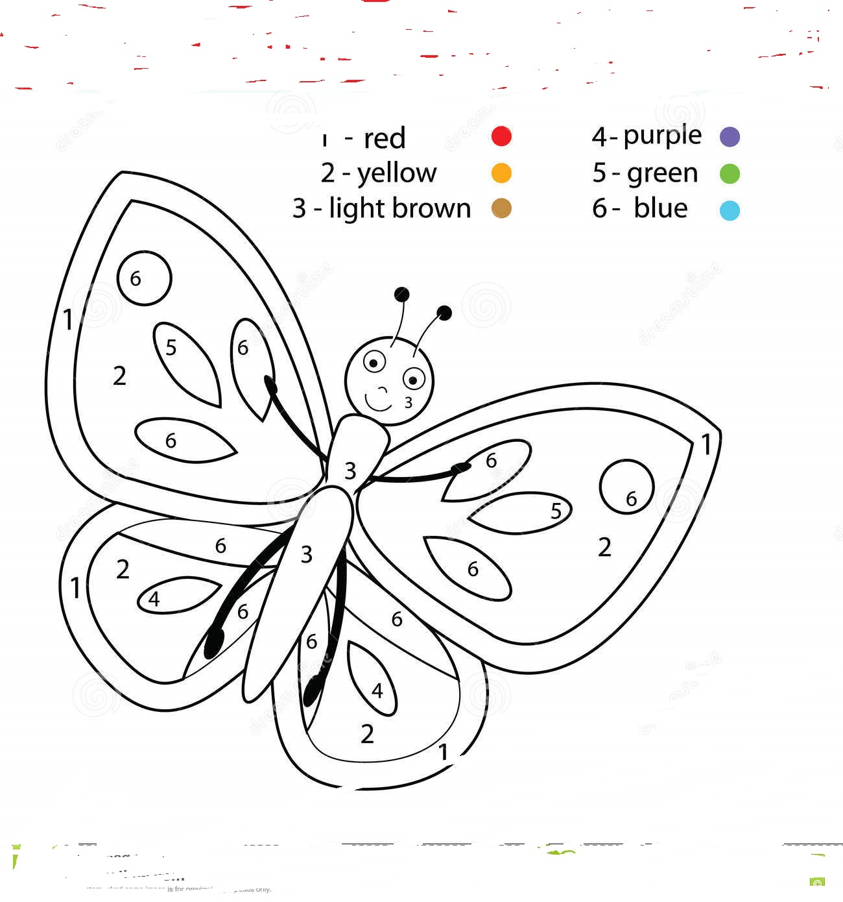**

**Q2.See and draw. /10**

**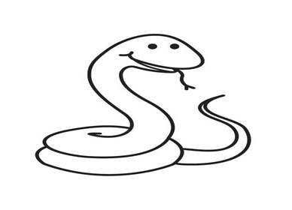**

**Q3.Complete the picture. /10**

**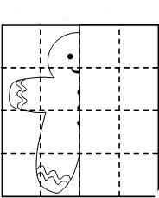**

**Q4.Draw an ant. /10**

**Note: 10 marks for notebook**

** *The* Knowledge City School**

**Mid-Term Examination (2019-20)**

**Class: III Paper: English**

|  |  |
| --- | --- |
| **Name:** | **Total Marks: /75** |
| **Date:** | **Total Marks obtained: /25** |
| **Paper setter: Arslan Akhtar Ali** | **Time: 2 hours 30 mins** |

**Q 1: COMPREHENSION**

**Read the passage carefully and answer the questions given at the end.(10)**

**Long ago, there were many donkeys. The donkeys worked hard and had no time to play, to rest in the grass, or just to relax.One day, two donkeys got fed up with working so hard. They went to see the wise old man."I have an idea," said the wise old man. "I will paint you, and no one will know you are donkeys."The wise old man got two pots of paint. One pot was filled with white paint, and the other was filled with black paint. First, he painted the donkeys white. Then he painted black stripes over the white paint."You don't look at all like donkeys," said the wise old man. "I will call you something else - zebras!"The zebras went to a field to lay in the grass. They did no work, and no one bothered them.Soon other donkeys saw them. They asked the zebras where they came from. When the zebras told the donkeys what happened, all the donkeys rushed to see the wise old man. "Make us into zebras, too," they cried.The old man could not paint the donkeys fast enough. Soon the donkeys grew restless. They began to kick and they knocked over the paint pots. The wise old man was out of paint.The painted donkeys became zebras. The unpainted donkeys had to return to work.**

**Q1.What were zebras before? /1 \_\_\_\_\_\_\_\_\_\_\_\_\_\_\_\_\_\_\_\_\_\_\_\_\_\_\_\_\_\_\_\_\_\_\_\_\_\_\_\_\_\_\_\_\_\_\_\_\_\_\_\_\_\_\_\_\_\_\_\_\_\_\_\_\_\_**

**\_\_\_\_\_\_\_\_\_\_\_\_\_\_\_\_\_\_\_\_\_\_\_\_\_\_\_\_\_\_\_\_\_\_\_\_\_\_\_\_\_\_\_\_\_\_\_\_\_\_\_\_\_\_\_\_\_\_\_\_\_\_\_\_\_\_**

**Q2.Who helped them? /1 \_\_\_\_\_\_\_\_\_\_\_\_\_\_\_\_\_\_\_\_\_\_\_\_\_\_\_\_\_\_\_\_\_\_\_\_\_\_\_\_\_\_\_\_\_\_\_\_\_\_\_\_\_\_\_\_\_\_\_\_\_\_\_\_\_\_**

**\_\_\_\_\_\_\_\_\_\_\_\_\_\_\_\_\_\_\_\_\_\_\_\_\_\_\_\_\_\_\_\_\_\_\_\_\_\_\_\_\_\_\_\_\_\_\_\_\_\_\_\_\_\_\_\_\_\_\_\_\_\_\_\_\_\_**

**Q3.Why were the donkeys upset? /2**

**Q4.What did the other donkeys do after looking at the zebras? /2**

**Q5. What happened in the end? /2**

**Q5. Suggest a suitable title for the story. /1**

**\_\_\_\_\_\_\_\_\_\_\_\_\_\_\_\_\_\_\_\_\_\_\_\_\_\_\_\_\_\_\_\_\_\_\_\_\_\_\_\_\_\_\_\_\_\_\_\_\_\_\_\_\_\_\_\_\_\_\_\_\_\_\_\_\_\_**

**Q6. Did you like the story? Give a reason. /1**

**Q 2: Write an essay on the topic. (5)**

**The weather I enjoy the most.**

**Q3: Write a short story with the help of given pictures after sequencing them. (5)**

**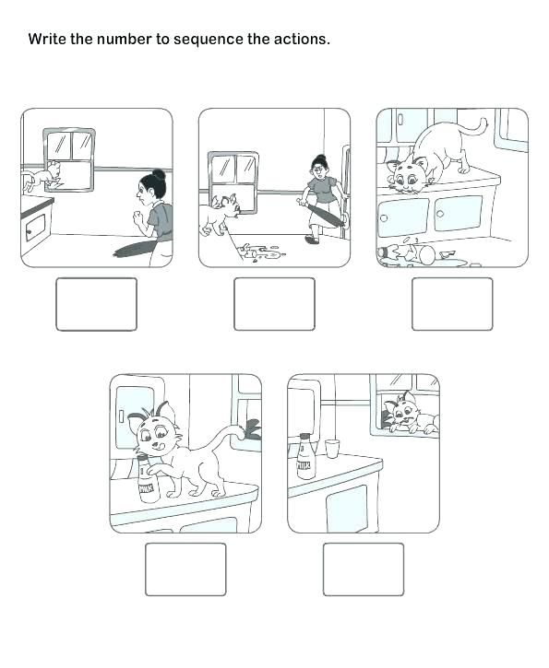**

**Q 4: Answer the following questions. (10)**

**(a) Why did Sue want to go down the road?**

**(b) Did Sue listen to what her mother told her?**

**(c) How did Sue’s mother try to teach Sue a lesson?**

**(d) Did Sue learn her lesson?**

**(e) Sue did not obey her mother; do you think she was right to do so?**

**……………………………………………………………………………………..**

**Q 5: Write the plurals of the following words. (5)**

|  |  |
| --- | --- |
| **Singulars** | **Plurals** |
| **Tree** |  |
| **Book** |  |
| **Bush** |  |
| **River** |  |
| **thrush** |  |
| **Baby** |  |
| **Class** |  |
| **Computer** |  |
| **Boss** |  |
| **Punch** |  |

**Q 6: Unscramble the given sentences. Do not forget capital letters and full stops! (5)**

1. **began the 1896 games in modern**
2. **is held the Olympic every Games four years**
3. **stadium the Greek athletes the first enter**
4. **during the games flame burns the Olympic**
5. **important Olympic part most the of is ceremony opening**

**Q7: Write the missing ee word. (5)**

1. **I’m going to Spain next ……………….. (wake, week, weed).**
2. **I can …………… (peck, pale, peel) this orange in one go.**
3. **I will …………… (meet, meat, meal) you at the bus stop.**
4. **The …………….. (deer, reed, dear) is in the park.**
5. **I have ………….. (been, bore, bone) waiting for you.**
6. **There are …………… (red, two, seventeen) boys.**
7. **The …………… (agreement, sentiment, interest) has been decided between both companies.**
8. **Sidra is a …………… (been, seen, keen) learner.**
9. **The American grass is always …………… (green, seem, teen).**
10. **My school …………… (shop, canteen, nineteen) contains hygienic food.**

**Q8: Write the correct word. (5)**

1. **A tiger has a long ………………. (train, tail, sail).**
2. **A ………………. (snail, train, stain) has its house on its back.**
3. **The snail left a ……………… (train, snail, trail) of slime.**
4. **I have a ……………… (pail, pain, paint) in my foot.**
5. **The Olympic Games are held every …………… (three, four, five) years.**
6. **The colours of the rings represent five …………… continents (oceans, continents, seasons).**
7. **As sly as a …………… (rat, fox, rabbit).**
8. **As busy as a …………… (elephant, bee, snail).**
9. **The lamb …………… (chirps, grunts, bleats) when it sees its mother.**
10. **The bear …………… (barks, croaks, growls) when it is angry.**

****

**The Knowledge City School**

**Mid-Term Examination (2019-20)**

**Class: III Paper: Mathematics**

|  |  |
| --- | --- |
| **Name:** | **Total Marks: 50** |
| **Date:** | **Total Marks obtained:** |
| **Paper setter: Sadia Batool** | **Time: 2 hours 30 mins** |

**Q1: Complete the following. /5**

1. **4000 + 300 + 10 + 1 = \_\_\_\_\_\_\_\_\_\_\_**
2. **7000 + \_\_\_\_\_\_\_ + 50 + 9 = 7659**
3. **6784 , 6845 , 6784 , \_\_\_\_\_\_\_**
4. **1000 + 500 + \_\_\_\_\_\_\_\_ + 5 = 1505**
5. **\_\_\_\_\_\_\_ + 600 + 5 = 8605**
6. **\_\_\_\_\_\_ , 7002 , 7001 , 7000**
7. **34 + 20 = \_\_\_\_\_\_\_\_**
8. **600 × 4 = \_\_\_\_\_\_\_**
9. **67 – 49 = \_\_\_\_\_\_\_**
10. **250 5 = \_\_\_\_\_\_\_**

**Q2: Fill the boxes with sign “<” or “>”. \2**

1. **6785 \_\_\_\_\_\_\_ 6875**
2. **3550 \_\_\_\_\_\_\_ 3055**
3. **2500 \_\_\_\_\_\_\_\_ 2050**
4. **8970 \_\_\_\_\_\_\_\_ 8790**

**Q3: Addition /8**

**2 0 3 5 8 6 3 5**

**+ 4 8 6 8 + 6 3 6 7**

**7 1 9 6 5 4 6 3**

**+ 8 3 5 6 + 8 6 0 7**

**Q4: Subtraction /8**

**8 3 0 4 7 0 0 8**

**\_ 2 8 9 7 \_ 3 7 9 5**

**6 0 0 0 5 9 5 3**

**\_ 4 3 8 6 \_ 4 6 6 7**

**Q5: There were 2642 new cars registered last month. There were 25 fewer new cars registered this month as compared to last month. How many new cars were registered altogether in the two moths? /3**

**Q6: Convert the following /4**

1. **5m 60 cm = \_\_\_\_\_\_ cm + \_\_\_\_\_\_\_ cm**

**= \_\_\_\_\_\_\_ cm**

1. **950 cm = \_\_\_\_\_\_ cm + \_\_\_\_\_\_\_ cm**

**= \_\_\_\_\_\_\_ cm**

**s**

1. **6 km 156 m = \_\_\_\_\_\_\_ m + \_\_\_\_\_\_\_ m**

**= \_\_\_\_\_\_\_\_ m**

1. **6987 = \_\_\_\_\_\_\_\_ m + \_\_\_\_\_\_\_\_ m**

**= \_\_\_\_\_\_\_\_ km \_\_\_\_\_\_\_ m**

**Q7: Salma had 3 times as many comic books as Nadeem. If Nadeem had 397 comic books, how many comic books did both of them have altogether? /3**

**Q8: Find quotient and remainder. /5**

1. **413 ÷ 3 ii) 739 ÷ 6**

**Q9: Fill in the blanks. /4**

1. **60 × 5 = \_\_\_\_\_\_\_\_\_**
2. **80 × 7 = \_\_\_\_\_\_\_\_\_**
3. **56 ÷ 8 = \_\_\_\_\_\_\_\_\_**
4. **45 ÷ 9 = \_\_\_\_\_\_\_\_\_**

**Q10: Hassan made 750 paper flowers. He gave an equal number of paper flowers to each of his 8 friends and kept the remaining.**

1. **How many paper flowers did each of his friends get?**

**(b) How many paper flowers did he keep? /4**

**Q11: There are 8 sections of class ll in a school. Each section has 49 pupils. If 189 are girls, how many are boys?**

** The Knowledge City School**

**Mid-Term Examination (2019-20)**

**Class: Ill Paper: Arts**

|  |  |
| --- | --- |
| **Name:** | **Total Marks: 50** |
| **Date:** | **Total Marks obtained:** |
| **Paper setter:Zaheen Fatima** | **Time: 2 hours 30 mins** |

**Q1.Color the given picture. /10**

**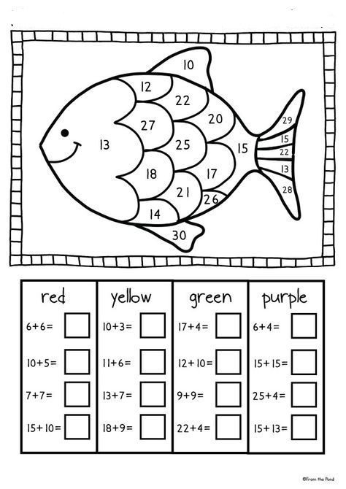**

**Q2.See and draw. /10**

**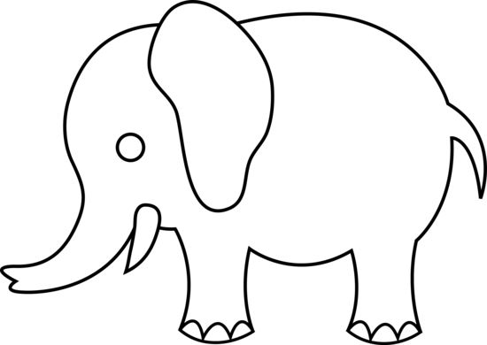**

**Q3.Complete the picture. /10**

**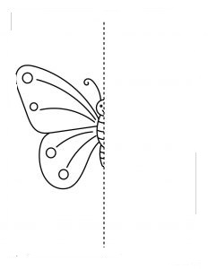**

**Q4.Draw a cycle. /10**

**Note: 10 marks for notebook**

** The Knowledge City School**

**Mid-Term Examination (2019-20)**

**Class: III Paper: English**

|  |  |
| --- | --- |
| **Name:** | **Total Marks: /75** |
| **Date:** | **Total Marks obtained: /25** |
| **Paper setter: Arslan Akhtar Ali** | **Time: 2 hours 30 mins** |

**Q 1: COMPREHENSION**

**Read the passage carefully and answer the questions given at the end.(10)**

**Long ago, there were many donkeys. The donkeys worked hard and had no time to play, to rest in the grass, or just to relax.One day, two donkeys got fed up with working so hard. They went to see the wise old man."I have an idea," said the wise old man. "I will paint you, and no one will know you are donkeys."The wise old man got two pots of paint. One pot was filled with white paint, and the other was filled with black paint. First, he painted the donkeys white. Then he painted black stripes over the white paint."You don't look at all like donkeys," said the wise old man. "I will call you something else - zebras!"The zebras went to a field to lay in the grass. They did no work, and no one bothered them.Soon other donkeys saw them. They asked the zebras where they came from. When the zebras told the donkeys what happened, all the donkeys rushed to see the wise old man. "Make us into zebras, too," they cried.The old man could not paint the donkeys fast enough. Soon the donkeys grew restless. They began to kick and they knocked over the paint pots. The wise old man was out of paint.The painted donkeys became zebras. The unpainted donkeys had to return to work.**

**Q1.What were zebras before? /1 \_\_\_\_\_\_\_\_\_\_\_\_\_\_\_\_\_\_\_\_\_\_\_\_\_\_\_\_\_\_\_\_\_\_\_\_\_\_\_\_\_\_\_\_\_\_\_\_\_\_\_\_\_\_\_\_\_\_\_\_\_\_\_\_\_\_**

**\_\_\_\_\_\_\_\_\_\_\_\_\_\_\_\_\_\_\_\_\_\_\_\_\_\_\_\_\_\_\_\_\_\_\_\_\_\_\_\_\_\_\_\_\_\_\_\_\_\_\_\_\_\_\_\_\_\_\_\_\_\_\_\_\_\_**

**Q2.Who helped them? /1 \_\_\_\_\_\_\_\_\_\_\_\_\_\_\_\_\_\_\_\_\_\_\_\_\_\_\_\_\_\_\_\_\_\_\_\_\_\_\_\_\_\_\_\_\_\_\_\_\_\_\_\_\_\_\_\_\_\_\_\_\_\_\_\_\_\_**

**\_\_\_\_\_\_\_\_\_\_\_\_\_\_\_\_\_\_\_\_\_\_\_\_\_\_\_\_\_\_\_\_\_\_\_\_\_\_\_\_\_\_\_\_\_\_\_\_\_\_\_\_\_\_\_\_\_\_\_\_\_\_\_\_\_\_**

**Q3.Why were the donkeys upset? /2**

**Q4.What did the other donkeys do after looking at the zebras? /2**

**Q5. What happened in the end? /2**

**Q5. Suggest a suitable title for the story. /1**

**\_\_\_\_\_\_\_\_\_\_\_\_\_\_\_\_\_\_\_\_\_\_\_\_\_\_\_\_\_\_\_\_\_\_\_\_\_\_\_\_\_\_\_\_\_\_\_\_\_\_\_\_\_\_\_\_\_\_\_\_\_\_\_\_\_\_**

**Q6. Did you like the story? Give a reason. /1**

**Q 2: Write an essay on the topic. (5)**

**The weather I enjoy the most.**

**Q3: Write a short story with the help of given pictures after sequencing them. (5)**

****

**Q 4: Answer the following questions. (10)**

**(a) Why did the turtle get cross when he heard what the people said?**

**(b) How do the baby animals keep warm?**

**(c) How did Sue’s mother try to teach Sue a lesson?**

**(d) Why do you think the Jumblies want to travel far away?**

**(e) What was the reason behind Majid’s chuckling?**

**……………………………………………………………………………………..**

**Q 5: Write the plurals of the following words. (5)**

|  |  |
| --- | --- |
| **Singulars** | **Plurals** |
| **tree** |  |
| **book** |  |
| **bush** |  |
| **river** |  |
| **thrush** |  |
| **baby** |  |
| **class** |  |
| **computer** |  |
| **boss** |  |
| **punch** |  |

**Q 6: Unscramble the given sentences. Do not forget capital letters and full stops! (5)**

1. **began the 1896 games in modern**
2. **is held the Olympic every Games four years**
3. **stadium the Greek athletes the first enter**
4. **during the games flame burns the Olympic**
5. **important Olympic part most the of is ceremony opening**

**Q7: Write the missing ee word. (5)**

1. **I’m going to Spain next ……………….. (wake, week, weed).**
2. **I can …………… (peck, pale, peel) this orange in one go.**
3. **I will …………… (meet, meat, meal) you at the bus stop.**
4. **The …………….. (deer, reed, dear) is in the park.**
5. **I have ………….. (been, bore, bone) waiting for you.**
6. **There are …………… (red, two, seventeen) boys.**
7. **The …………… (agreement, sentiment, interest) has been decided between both companies.**
8. **Sidra is a …………… (been, seen, keen) learner.**
9. **The American grass is always …………… (green, seem, teen).**
10. **My school …………… (shop, canteen, nineteen) contains hygienic food.**

**Q8: Write the correct word. (5)**

1. **A tiger has a long ………………. (train, tail, sail).**
2. **A ………………. (snail, train, stain) has its house on its back.**
3. **The snail left a ……………… (train, snail, trail) of slime.**
4. **I have a ……………… (pail, pain, paint) in my foot.**
5. **The Olympic Games are held every …………… (three, four, five) years.**
6. **The colours of the rings represent five …………… continents (oceans, continents, seasons).**
7. **As sly as a …………… (rat, fox, rabbit).**
8. **As busy as a …………… (elephant, bee, snail).**
9. **The lamb …………… (chirps, grunts, bleats) when it sees its mother.**
10. **The bear …………… (barks, croaks, growls) when it is angry.**

** The Knowledge City School**

**Mid-Term Examination (2019-20)**

**Class: IV Paper: Mathematics**

|  |  |
| --- | --- |
| **Name:** | **Total Marks: 50** |
| **Date:** | **Total Marks obtained:** |
| **Paper setter:Marium Batool** | **Time: 2 hours 30 mins** |

**Q1: Write in words (5)**

1. **14320**

**\_\_\_\_\_\_\_\_\_\_\_\_\_\_\_\_\_\_\_\_\_\_\_\_\_\_\_\_\_\_\_\_\_\_\_\_\_\_\_\_\_\_\_\_\_\_\_\_\_\_\_**

1. **10934**

**-----------------------------------------------------------------------------------**

1. **43700**

**\_\_\_\_\_\_\_\_\_\_\_\_\_\_\_\_\_\_\_\_\_\_\_\_\_\_\_\_\_\_\_\_\_\_\_\_\_\_\_\_\_\_\_\_\_\_\_\_\_\_\_\_\_**

**d.30189**

**e.54341**

**-------------------------------------------------------------------------------------**

**Q2: Write first five factors (5)**

1. **14 : \_\_\_\_\_\_\_\_\_\_\_\_\_\_\_\_\_\_\_\_\_\_\_\_\_\_\_\_\_\_\_\_\_\_\_\_\_\_\_\_\_\_\_\_\_\_\_\_\_\_**
2. **45: \_\_\_\_\_\_\_\_\_\_\_\_\_\_\_\_\_\_\_\_\_\_\_\_\_\_\_\_\_\_\_\_\_\_\_\_\_\_\_\_\_\_\_\_\_\_\_\_\_\_**
3. **48: \_\_\_\_\_\_\_\_\_\_\_\_\_\_\_\_\_\_\_\_\_\_\_\_\_\_\_\_\_\_\_\_\_\_\_\_\_\_\_\_\_\_\_\_\_\_\_\_\_\_**
4. **12: \_\_\_\_\_\_\_\_\_\_\_\_\_\_\_\_\_\_\_\_\_\_\_\_\_\_\_\_\_\_\_\_\_\_\_\_\_\_\_\_\_\_\_\_\_\_\_\_\_\_**
5. **36: \_\_\_\_\_\_\_\_\_\_\_\_\_\_\_\_\_\_\_\_\_\_\_\_\_\_\_\_\_\_\_\_\_\_\_\_\_\_\_\_\_\_\_\_\_\_\_\_\_\_**

**Q3: Write least common multiples of (6)**

1. **Multiples of 3\_\_\_\_\_\_\_\_\_\_\_\_\_\_\_\_\_\_\_\_\_\_**

**Multiples of 6\_\_\_\_\_\_\_\_\_\_\_\_\_\_\_\_\_\_\_\_\_\_**

**L.C.M 0f 3 and 6 \_\_\_\_\_\_\_\_\_\_\_\_\_\_\_\_\_\_\_**

1. **Multiples of 8 \_\_\_\_\_\_\_\_\_\_\_\_\_\_\_\_\_\_\_\_\_\_**

**Multiples of 4\_\_\_\_\_\_\_\_\_\_\_\_\_\_\_\_\_\_\_\_\_\_**

**L.C.M 0f 8 and 4 \_\_\_\_\_\_\_\_\_\_\_\_\_\_\_\_\_\_\_**

**c. Multiples of 5 \_\_\_\_\_\_\_\_\_\_\_\_\_\_\_\_\_\_\_\_\_**

**Multiples of 7 \_\_\_\_\_\_\_\_\_\_\_\_\_\_\_\_\_\_\_\_**

**L.C.M of 5 and 7 \_\_\_\_\_\_\_\_\_\_\_\_\_\_\_\_\_\_**

**Q4:Round off the numbers nearest hundred (5)**

1. **789 = \_\_\_\_\_\_\_\_\_\_\_\_\_\_\_\_\_\_\_\_\_\_\_\_\_\_\_\_\_\_\_\_\_\_\_\_**
2. **154 = \_\_\_\_\_\_\_\_\_\_\_\_\_\_\_\_\_\_\_\_\_\_\_\_\_\_\_\_\_\_\_\_\_\_\_\_**
3. **31698 = \_\_\_\_\_\_\_\_\_\_\_\_\_\_\_\_\_\_\_\_\_\_\_\_\_\_\_\_\_\_\_\_\_\_\_\_**
4. **67475= \_\_\_\_\_\_\_\_\_\_\_\_\_\_\_\_\_\_\_\_\_\_\_\_\_\_\_\_\_\_\_\_\_\_\_\_**
5. **36081 = \_\_\_\_\_\_\_\_\_\_\_\_\_\_\_\_\_\_\_\_\_\_\_\_\_\_\_\_\_\_\_\_\_\_\_\_**
6. **178= \_\_\_\_\_\_\_\_\_\_\_\_\_\_\_\_\_\_\_\_\_\_\_\_\_\_\_\_\_\_\_\_\_\_\_\_**
7. **941= \_\_\_\_\_\_\_\_\_\_\_\_\_\_\_\_\_\_\_\_\_\_\_\_\_\_\_\_\_\_\_\_\_\_\_\_**
8. **1091= \_\_\_\_\_\_\_\_\_\_\_\_\_\_\_\_\_\_\_\_\_\_\_\_\_\_\_\_\_\_\_\_\_\_\_\_**
9. **1931= \_\_\_\_\_\_\_\_\_\_\_\_\_\_\_\_\_\_\_\_\_\_\_\_\_\_\_\_\_\_\_\_\_\_\_\_**
10. **5701= \_\_\_\_\_\_\_\_\_\_\_\_\_\_\_\_\_\_\_\_\_\_\_\_\_\_\_\_\_\_\_\_\_\_\_\_**

**Q5:Solve the following (10)**

**i) 576 x 36 ii) 329 x 14**

**iii) 3895 ÷ 5 iv)7290 ÷ 9**

**v) 3918 ÷ 6**

**Q6: 7 packets contain1092 envelopes. How many envel0pes are there in each packets? (1)**

**Q7: Muhammad jogged a distance of km. Kelvin jogged a distance of km. John jogged a distance of km. What was the total distance the three boys jogged? (3)**

**Q8: Solve fractions (6)**

**lll. 3 + 5**

**Q9:Solve fraction to its simple form. (6)**

1. **x 700**
2. **x 77**

**lll. of 48**

**Q10:Mohsin recorded the colours of the cars in his school car park. There were 14 white cars, 10 blue cars, 2 yellow cars, 8 silver-grey cars, and 4 red cars.**

**Present this information in the table and answer the following question (3s)**

|  |  |
| --- | --- |
| **Colour** | **Numbers of cars** |
| **White** |  |
| **Blue** |  |
| **Yellow** |  |
| **Silver-grey** |  |
| **red** |  |

1. **Which is the most popular colour?**
2. **Which is the least popular colour?**
3. **How many cars are not white?**
4. **What is the total numbers of cars in the car park?**

** The Knowledge City School**

**Mid-Term Examination (2019-20)**

**Class: IV Paper: Arts**

|  |  |
| --- | --- |
| **Name:** | **Total Marks: 50** |
| **Date:** | **Total Marks obtained:** |
| **Paper setter: Muneeza** | **Time: 2 hours 30 mins** |

**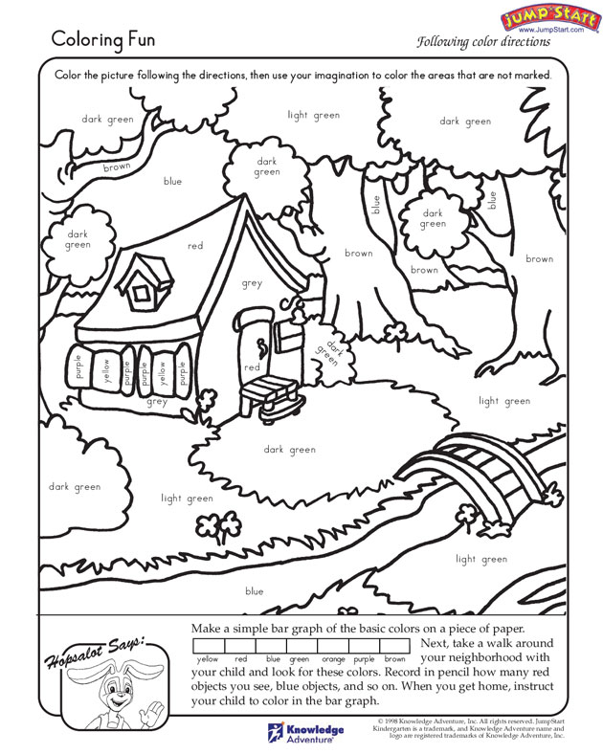Q1: Colour the given picture by using one type of stock. 10**

**Q2: Complete the picture? (10)**

**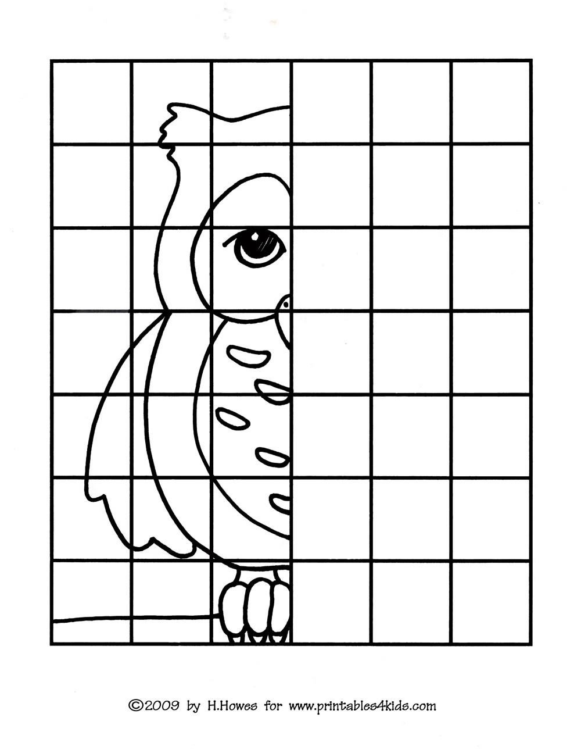**

**Q: 3 Help mother hen to find the way and colour the path? 10**

**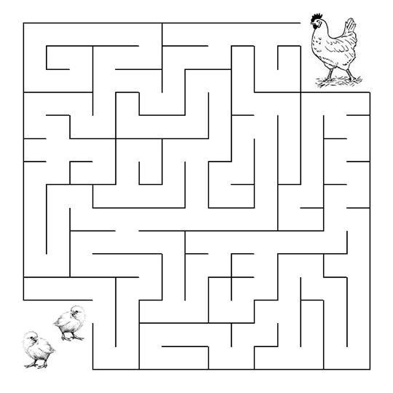**

**Q4.Make a pinwheel with the help of color paper? 10**

**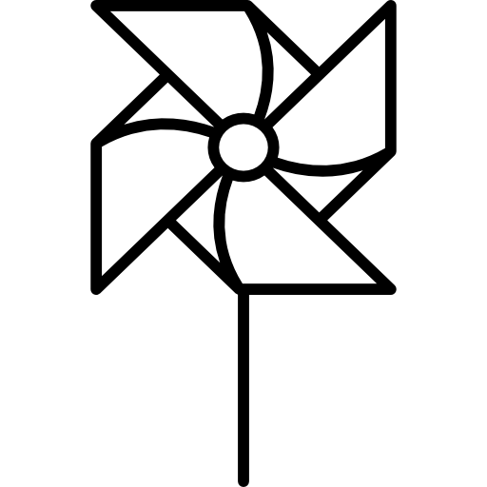**

**Note: 10 marks for notebook**

******

**The Knowledge City School**

**Mid-Term Examination (2019-20)**

**Class: IV Paper: English**

|  |  |
| --- | --- |
| **Name:** | **Total Marks: /75** |
| **Date:** | **Total Marks obtained: /25** |
| **Paper setter: Arslan Akhtar Ali** | **Time: 2 hours 30 mins** |

**Q 1: COMPREHENSION**

**Read the passage carefully and answer the questions given at the end. (10)**

**On July 1969, people all over the world sat and watched their television sets. Two men from Earth had landed on the Moon and were about to disembark their spacecraft and step onto the Moon’s surface. The astronauts were well-equipped. Their specially designed spacesuits would have save them from the great heat outside their spaceship. They had air tanks on their backs that would help them breathe when they walked on the Moon.**

**a: Why were people watching TV on 20 July 1969?**

**b: Why did the men wear spacesuits?**

**c: What did they carry on their backs?**

**d: Write the sentences of following words:**

**Surface:**

**Spacecraft:**

**e: Suggest a suitable topic for the passage.**

**f: Write down any 4 common nouns from the passage:**

**\_\_\_\_\_\_\_\_\_\_\_\_\_\_\_\_\_\_\_\_\_\_\_\_\_\_\_\_\_\_\_\_\_\_\_\_\_\_\_\_\_\_\_\_\_\_\_\_\_\_\_\_\_\_\_\_\_\_\_\_\_\_\_\_\_\_\_\_\_\_\_\_\_\_\_\_\_\_\_\_\_\_\_\_\_\_\_\_\_\_\_\_\_\_\_\_\_\_\_\_\_\_\_\_\_\_\_\_\_\_\_\_\_\_\_\_\_\_\_\_\_\_\_\_\_\_\_\_\_\_\_\_\_\_\_\_\_\_\_\_\_\_\_\_\_\_\_\_\_\_\_\_\_\_\_\_\_\_\_**

**Q 2: Write an essay on the topic.(5)**

**The changes I would like to bring in my school.**

**\_\_\_\_\_\_\_\_\_\_\_\_\_\_\_\_\_\_\_\_\_\_\_\_\_\_\_\_\_\_\_\_\_\_\_\_\_\_\_\_\_\_\_\_\_\_\_\_\_\_\_\_\_\_\_\_\_\_\_\_\_\_\_\_\_\_\_\_\_\_\_\_\_\_\_\_\_\_**

**Q3: Write a letter to your father telling him about your progress in studies.(5)**

**Q 4: Answer the following questions. (10)**

**(a) Why does the poet load his boat with flowers?**

**(b) Why Ms Reza was complaining to Mr Salim?**

**(c) What presents did Deeba receive and from whom?**

**(d) What had Rafay done?**

**(e) What happens in the poet’s dream?**

**Q 5: Complete the poem. (5)**

**One fine day in the middle of the ………………..**

**Two good boys got up to ………………..**

**Three blind men to see fair ………………..**

**With forty minutes to shout ………………..**

**Back to back they faced ………………..**

**Took out their swords and shot each ………………..**

**A deaf policeman heard the ………………..**

**And if you don’t believe its ………………..**

**Ask the blind men, they saw it ………………..**

**Q 6: Write where or were and there or their appropriately. (5)**

1. **The swallows were ……………….. with ……………….. friends.**
2. **Some birds obtain ……………….. food by digging with ……………….. bills.**
3. **……………….. is a kingfisher on that rock over …………………**
4. **……………….. were hundreds of crows.**
5. **The swallows built their ……………….. nests.**
6. **……………….. did you go last night ?**
7. **……………….. there many elephants ?**
8. **We don’t know ……………….. the teachers ………………..**
9. **The new houses are ……………….. the old markets ……………….. held.**
10. **……………….. in Europe ……………….. you going to go on your holidays.**

**Q7: Write two, too or to. (2.5)**

1. **Annie found it ……………….. difficult ……………….. crawl.**
2. **She went ……………….. the bathroom.**
3. **I was ……………….. frightened.**
4. **Whe she broke the ……………….. cups, dad spoke gently ……………….. her.**
5. **The doll was ……………….. expensive ……………….. buy.**
6. **It was ……………….. early for the baby ……………….. to go to bed.**

**Q8: Encircle the adjectives in given sentences. (2.5)**

1. **The new girl came into the big school.**
2. **She had silky black hair and dark eyes.**
3. **She held her shiny blue bag tightly.**
4. **In the noisy playground were strange, staring faces.**
5. **Then a little girl came up and took her to a quiet room.**

**Q9: Write meanings and make sentences of the given words. (5)**

|  |  |  |
| --- | --- | --- |
| **Word** | **Meaning** | **Sentence** |
|  |  |  |
|  |  |
|  |  |  |
|  |  |
|  |  |  |
|  |  |
|  |  |  |
|  |  |
|  |  |  |
|  |  |